 | Looks Like… | Feels Like… | I Can…
5 | I can’t handle this. I might lose control.  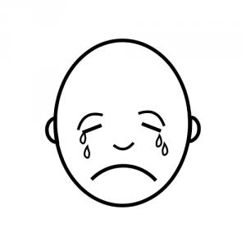
4 | This can really upset me.  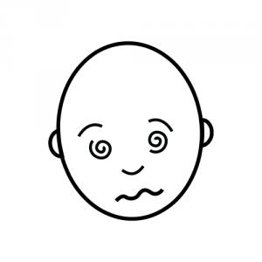
3 | This can make me feel nervous.  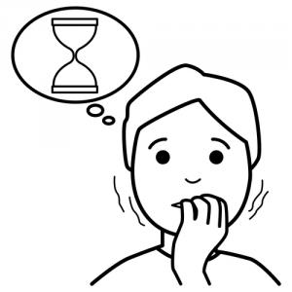
2 | Sometimes this bothers me.  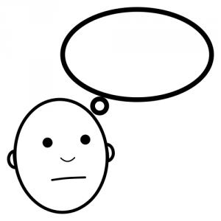
1 | This never bothers me! 